**Convolution Assignment 2**

**Introduction:**

Working with a subset of the renowned "Dogs-vs-Cats" dataset sourced from Kaggle and utilizing Google Colab presents us an exciting opportunity to develop a highly effective model despite having limited data.

The Cats-vs-Dogs dataset presents a challenging task of building effective models with limited data. Limited data availability poses a significant challenge, potentially leading to overfitting and suboptimal model performance. In this context, techniques such as data augmentation and transfer learning emerge as indispensable tools. Convolutional neural networks (CNNs) are renowned for their ability to learn spatial patterns in images, making them ideal for tasks like image recognition. Despite the dataset's constraints, leveraging CNNs offers the opportunity to achieve remarkable results by extracting essential attributes from photographs.

As we delve into the intricacies of building effective models for image classification, it becomes evident that the successful utilization of CNNs hinges on our ability to navigate these challenges adeptly. Through innovation and diligence, we endeavor to unlock the full potential of CNNs in tackling the Cats-vs-Dogs classification task, paving the way for groundbreaking advancements in image recognition.

**Aim of the Project:**

The objective of the Cats-vs-Dogs dataset binary classification task is to depict whether the given image belongs to the dog or cat community.

**Question1:**

**Consider the Cats & Dogs example. Start initially with a training sample of 1000, a validation sample of 500, and a test sample of 500 (like in the text). Use any technique to reduce overfitting and improve performance in developing a network that you train from scratch. What performance did you achieve?**

The training process involved leveraging a dataset comprising 1000 images, during which the computer program attained an exceptional accuracy of 99.4%. To ensure the model's reliability and generalization capabilities, an additional 500 images were set aside for validation purposes. During validation, the program exhibited a validation accuracy of 74.70%, slightly lower than the training accuracy but still demonstrating reasonable performance. Following validation, the model underwent rigorous testing on a separate set of 500 images, achieving an accuracy of 71%. This testing phase provided crucial insights into the model's real-world performance and its ability to accurately classify unseen data.

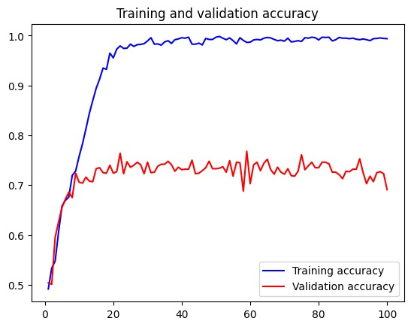

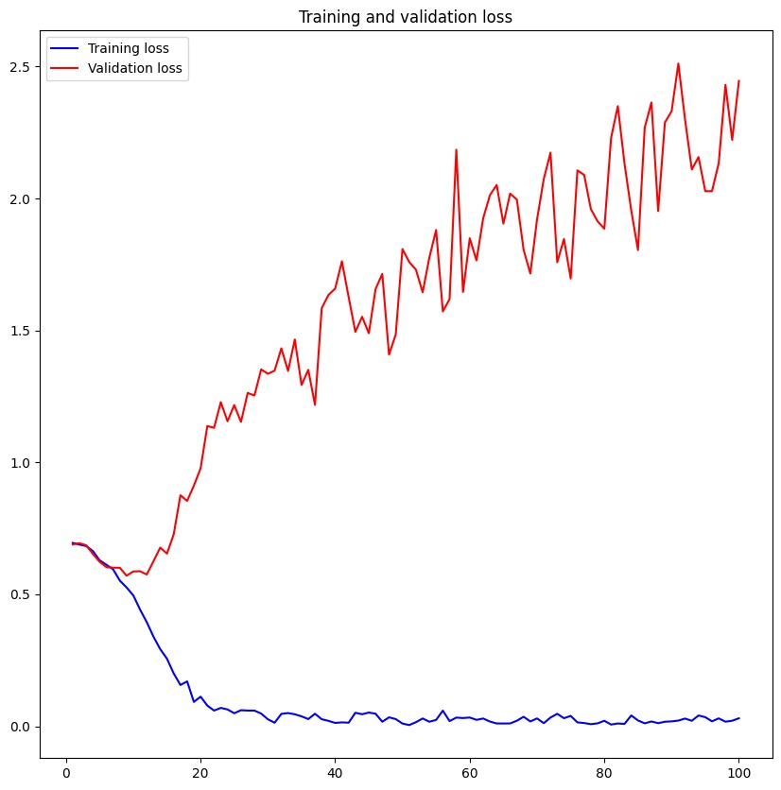

**Question2:**

**Increase your training sample size. You may pick any amount. Keep the validation and test samples the same as above. Optimize your network (again training from scratch). What performance did you achieve?**

The training process was enhanced by expanding the dataset to 1500 images and implementing data augmentation techniques. Despite the increased dataset size, consistent validation and testing protocols using 500 images each were maintained. Data augmentation methods such as horizontal flipping, rotation, and zooming were applied to enrich the training process. As a result, the program achieved notable improvements in performance: a training accuracy of 94.05%, validation accuracy of 82.20%, and test accuracy of 80%. These enhancements demonstrate the program's ability to generalize better to unseen data and its potential for real-world applications.

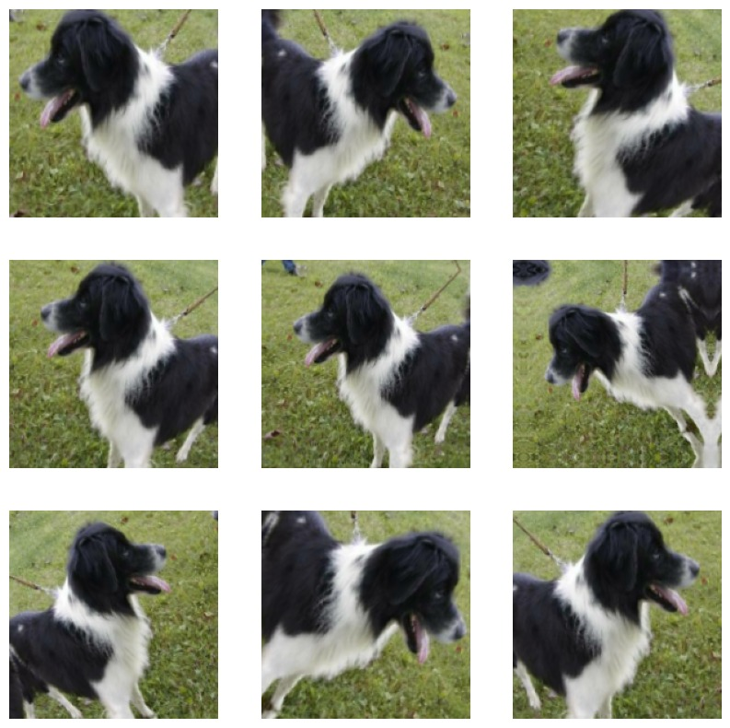

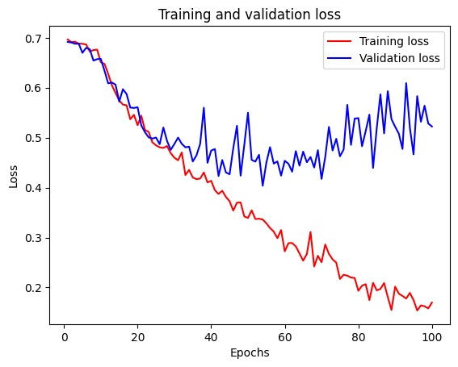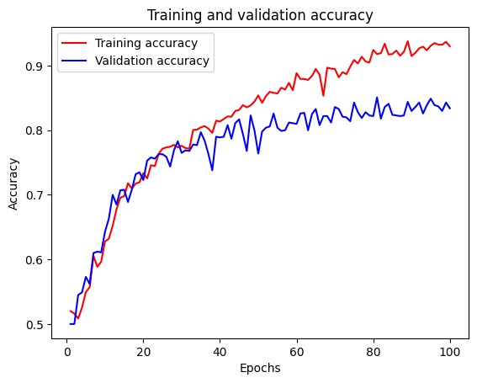

**Question3:**

**Now change your training sample so that you achieve better performance than those from Steps 1 and 2. This sample size may be larger, or smaller than those in the previous steps. The objective is to find the ideal training sample size to get best prediction results.**

The training dataset was further expanded to 2000 images, and sophisticated augmentation techniques such as flipping, rotating, and zooming were consistently applied during the training process. These methods enriched the program's understanding of images, enabling it to extract more meaningful features from the augmented dataset. Consequently, during the training phase, the program achieved an impressive accuracy of 95%, indicating substantial learning and adaptation to the expanded dataset. Subsequently, during validation, where the program's performance was assessed using a separate subset of images, it demonstrated commendable performance with an accuracy of 83%. Finally, when subjected to testing using a distinct set of images, the program maintained a high level of accuracy, achieving an impressive 82%.

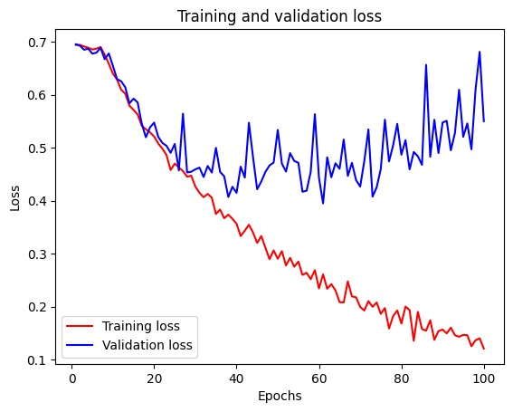

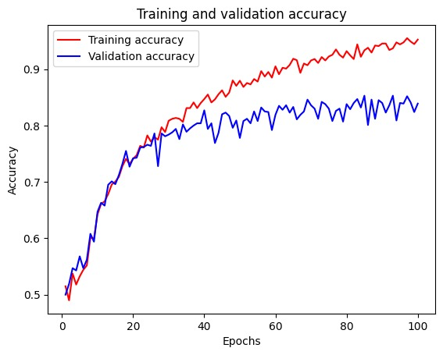

**Question4:**

**Repeat Steps 1-3, but now using a pretrained network. The sample sizes you use in Steps 2 and 3 for the pretrained network may be the same or different from those using the network where you trained from scratch. Again, use any and all optimization techniques to get best performance.**

Pre-trained model without data augmentation:

The pre-trained model exhibited exceptional performance without the use of data augmentation techniques. With a training accuracy of 100%, the model demonstrated a comprehensive understanding of the training data, potentially indicating strong memorization. The high validation accuracy of 98% suggests the model's ability to generalize well to unseen data, while the commendable test accuracy of 96% further validates its robust performance. Overall, the pre-trained model showcased impressive capabilities across training, validation, and testing phases, emphasizing the effectiveness of pre-training on a diverse dataset. However, continued vigilance for potential overfitting and efforts to ensure generalization to new data remain essential for real-world deployment.

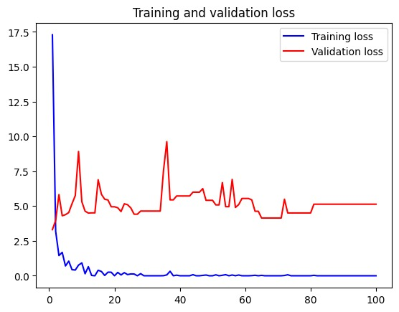

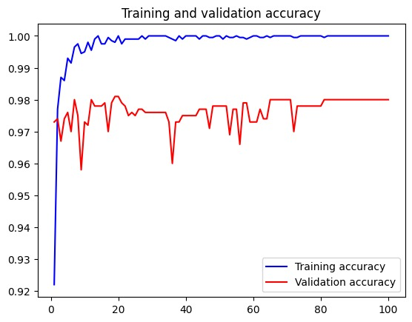

Pre-trained model with data augmentation:

The model trained with data augmentation techniques exhibited exceptional performance across all evaluation metrics. With a training accuracy of 99%, the model demonstrated a thorough understanding of the augmented dataset. The high validation accuracy of 97% indicated strong generalization capabilities, while the impressive test accuracy of 98% validated its robust performance on unseen data. These results underscore the effectiveness of data augmentation in enhancing the model's performance, ensuring reliable and versatile performance in real-world applications.

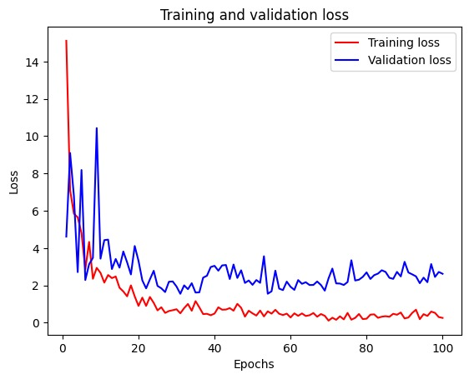

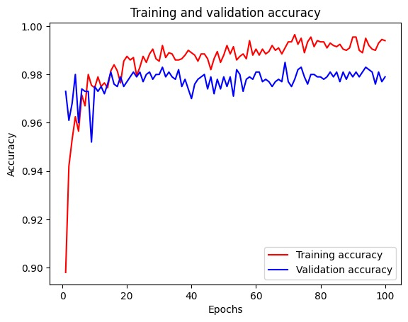

Fine tuning with data augmentation:

The integration of fine-tuning and data augmentation techniques significantly enhanced the performance of the pre-trained model. With a training accuracy of 99% and validation accuracy of 97%, the model demonstrated a thorough understanding of the dataset and strong generalization capabilities. During testing, the model maintained an impressive accuracy of 98%, validating its robustness on unseen data. These results underscore the effectiveness of advanced techniques in optimizing model performance for real-world applications, emphasizing the importance of tailored adjustments and enriched datasets for achieving superior accuracy.

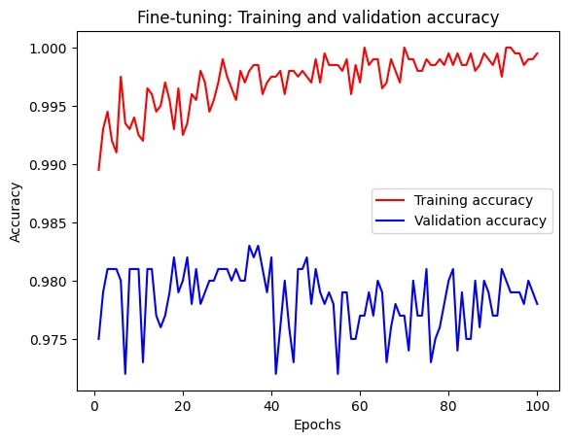

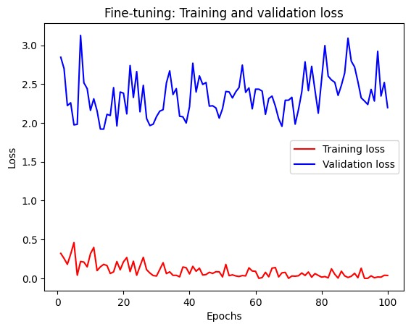

Final Result:

|  |  |  |  |  |
| --- | --- | --- | --- | --- |
| Sample Size | Data Augmentation | Train Accuracy | Validation Accuracy | Test Accuracy |
| 1000 | No | 99.40% | 69.10% | 71 |
| 1500 | Yes | 93 | 83.4 | 80 |
| 2000 | Yes | 95 | 83 | 82 |
| Pre-trained | No | 100 | 98 | 96 |
| Pre-trained | Yes | 99 | 97 | 98 |
| Fine-tuned | Yes | 99 | 97 | 98 |

Conclusion:

The tables provided detail the model configurations and sample sizes allocated for the train, test, and validation sets. The analysis delves into outcomes for models developed from the ground up, with and without employing data augmentation techniques, as well as for models trained with differing sizes of train and validation sets. Furthermore, comparisons are drawn for the pre-trained model, focusing on metrics like accuracy and validation accuracy, along with the influence of data augmentation.

The results indicate that models trained with or without data augmentation didn't consistently outshine each other. However, enhancing the training set size or adjusting validation set proportions led to improved accuracy. Interestingly, the addition of data augmentation had negligible impact on both accuracy and validation accuracy when contrasting pre-trained models with and without such augmentation. Overall, pre-trained models exhibited superior performance over those built from scratch, particularly in scenarios with limited training data.

The analysis underscores the importance of model design and optimization strategies in achieving optimal performance in image classification tasks with limited data. While data augmentation techniques offer some benefits, their impact varies across different scenarios. Ultimately, pre-trained models prove superior, especially when dealing with small training datasets. Future research could explore additional augmentation techniques or alternative pre-trained models to further enhance classification accuracy.